Atilla Genc

Homework 2

Steps for installing Jenkins

1. Install Java:
   1. >> sudo yum install java-1.8.0-openjdk
   2. >> java -version

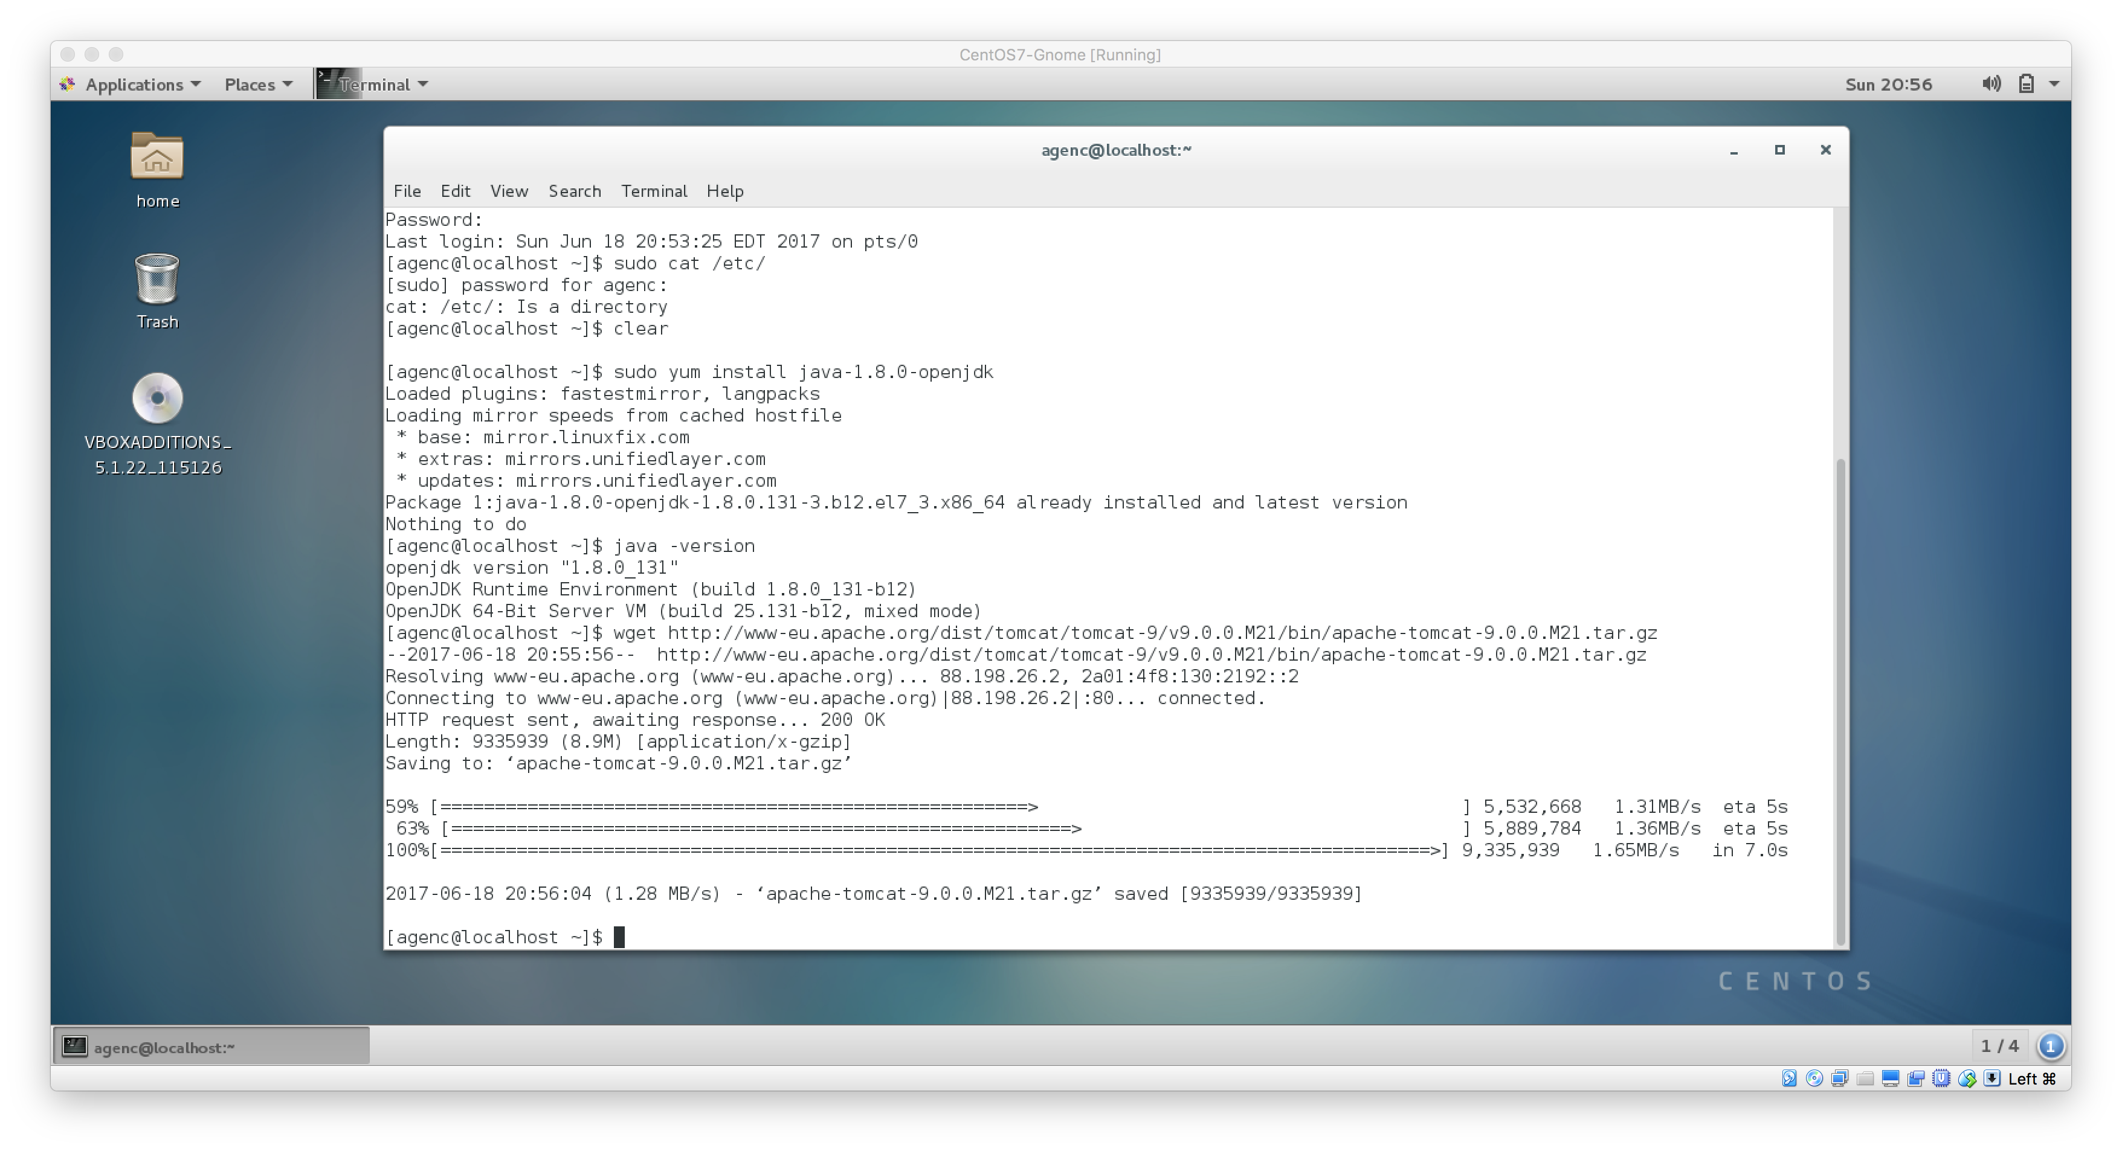

1. Install Apache Tomcat 9:
   1. >> sudo yum install wget http://www-eu.apache.org/dist/tomcat/tomcat-9/v9.0.0.M21/bin/apache-tomcat-9.0.0.M21.tar.gz
   2. >> chmod 755 apache-tomat-9.0.0.M21.tar.gz
   3. >> tar xzf apache-tomat-9.0.0.M21.tar.gz

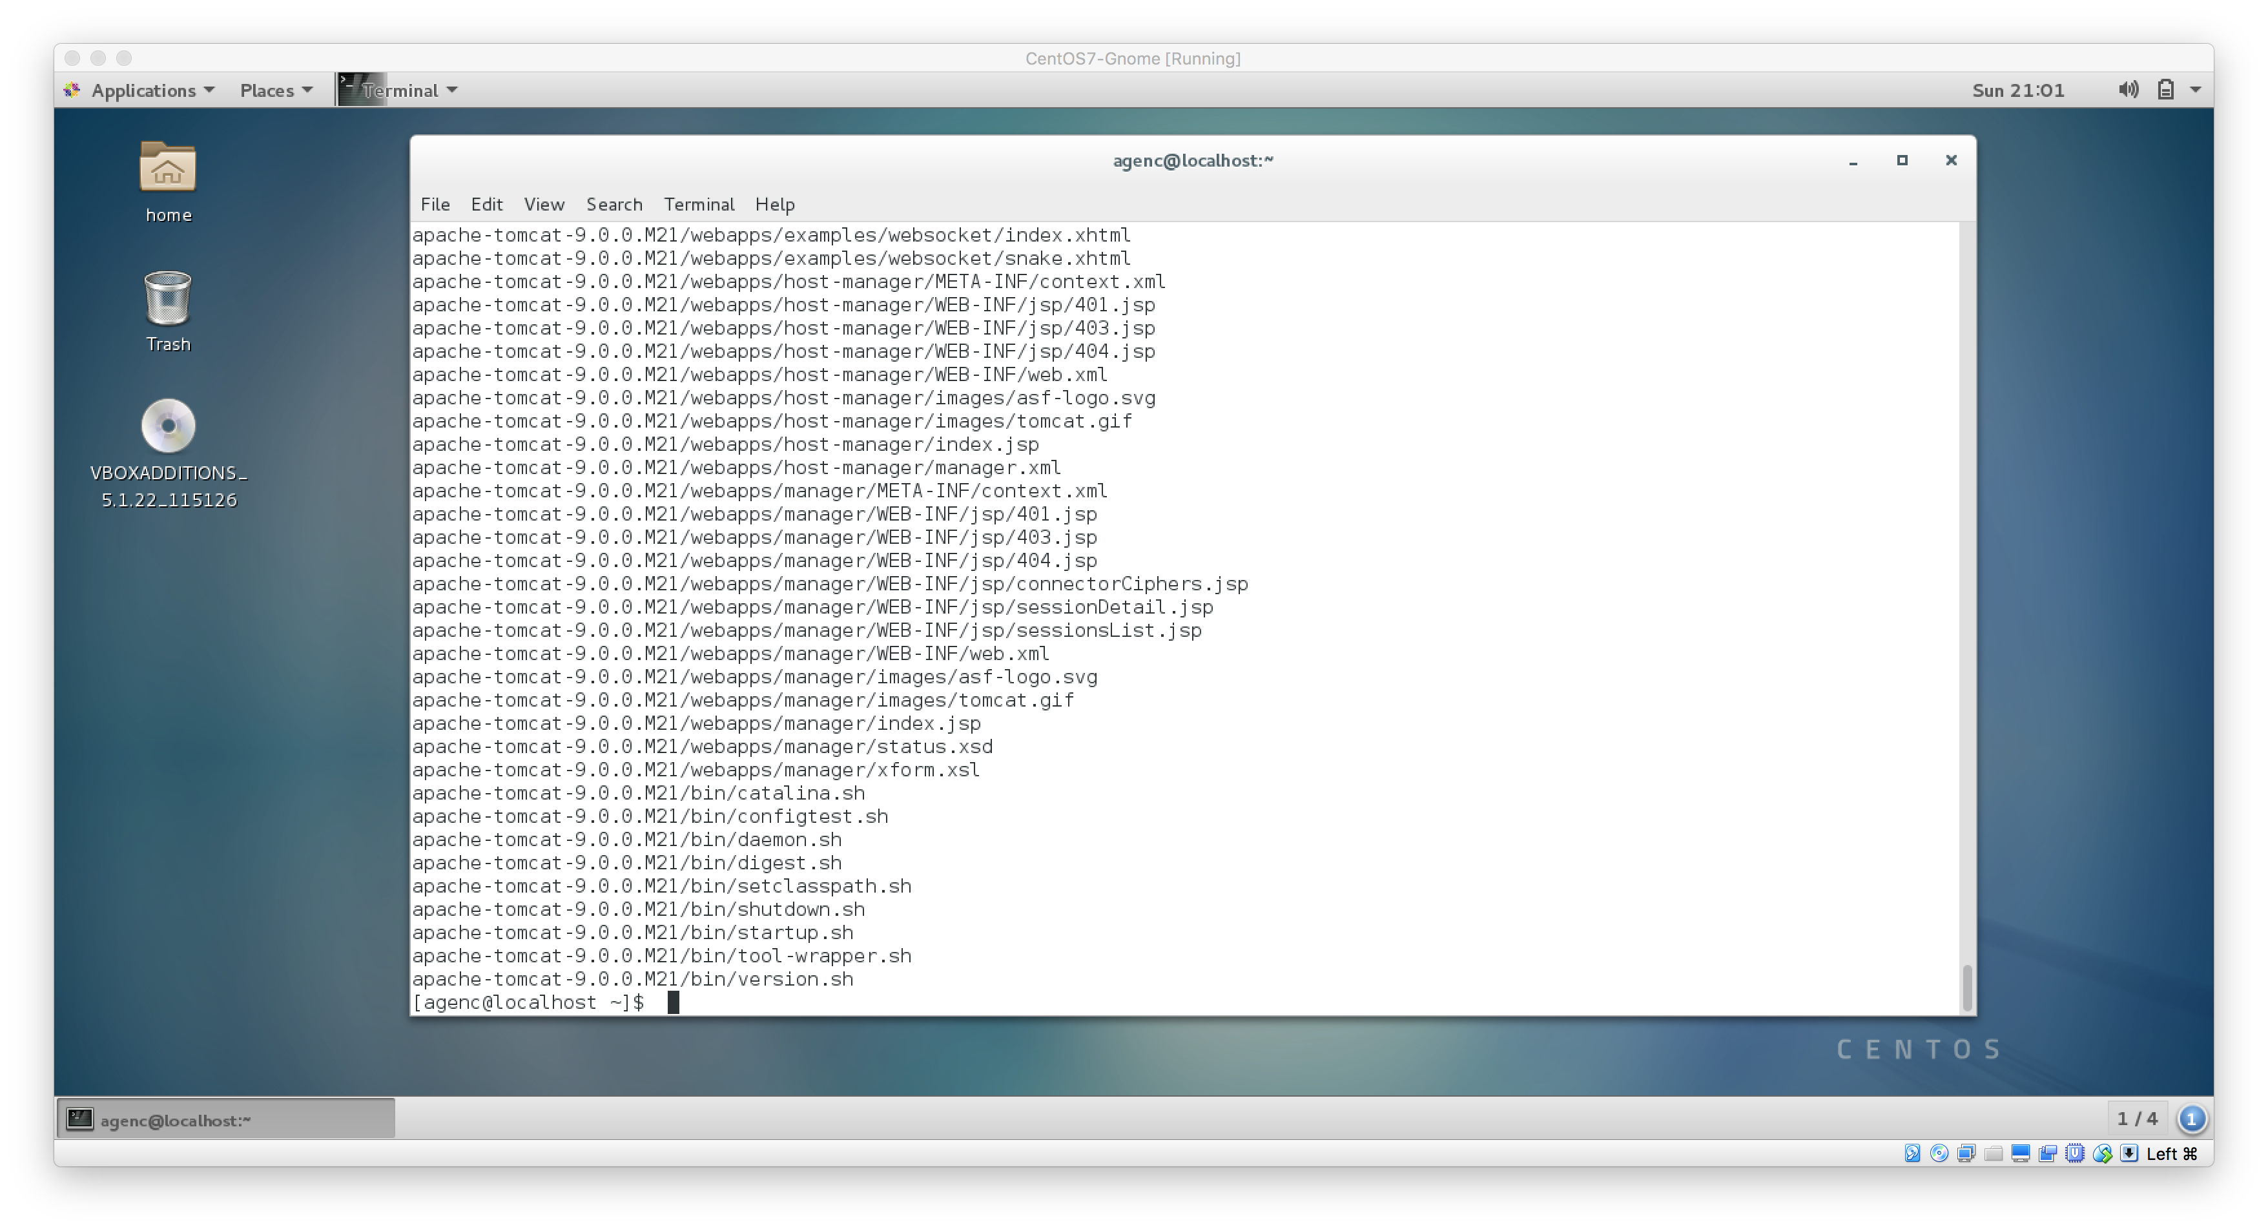

* 1. >> vi /home/kkavuri/tomcat9/conf/tomcat-users.xml

<?xml version="1.0" encoding="UTF-8?>

<tomcat-users>

<role rolename="manager-gui"/>

<role rolename="manager-script"/>

<role rolename="manager-jmx"/>

<role rolename="manager-status"/>

<role rolename="admin-gui"/>

<role rolename="admin-script"/>

<user username="kkavuri" password="xxxxx" roles="manager-gui,manager-script,manager-jmx,manager-status,admin-gui,admin-script"/>

</tomcat-users>

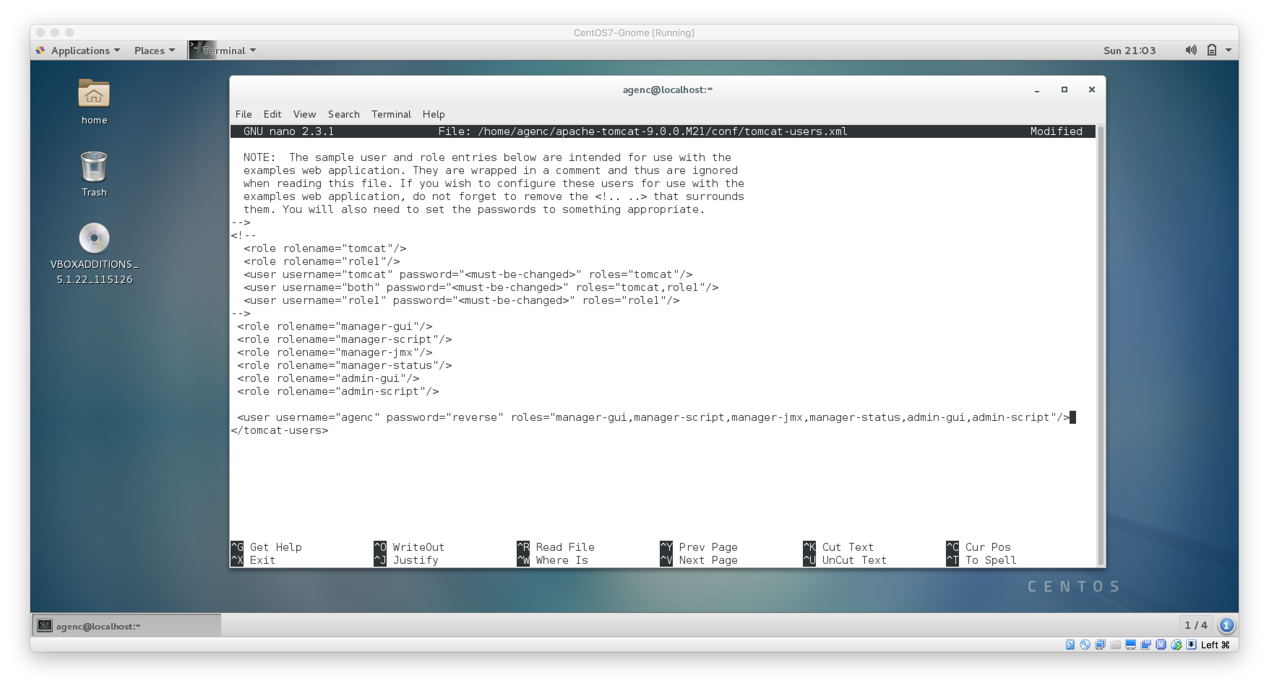

* 1. >> cd tomcat9
  2. >> ./bin/startup.sh

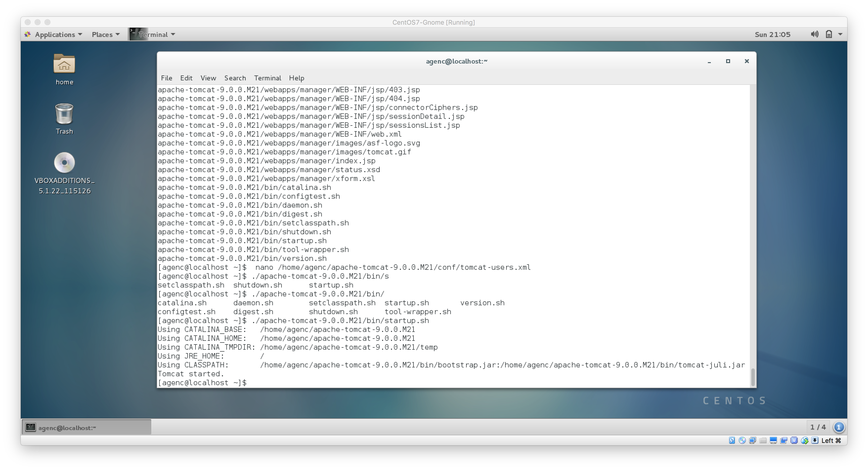

1. download Jenkins war file
   1. >> cd
   2. >> wget http://updates.jenkins-ci.org/download/war/2.7.3/jenkins.war

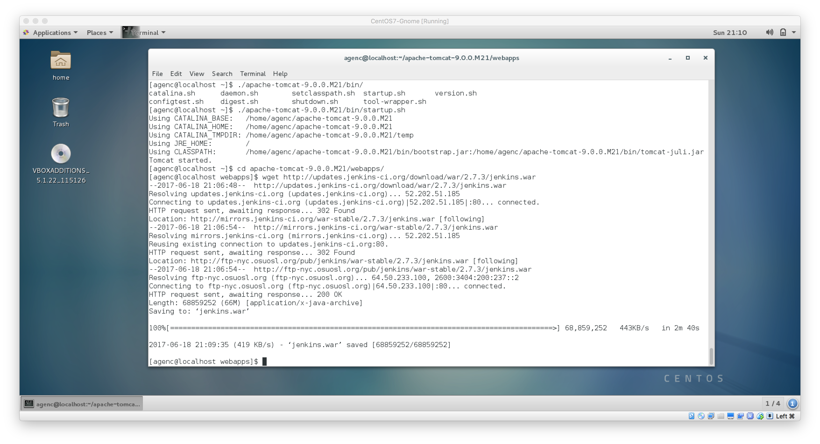

1. Deploy Jenkins war File
   1. copy the Jenkins.war file in ~/tomcat9/webapps folder
   2. open your browser and access localhost:8080
   3. click on the Manager App
   4. Enter your username and password
   5. OR
   6. For standalone:
   7. >> Java –jar Jenkins.war –httpPort=9090

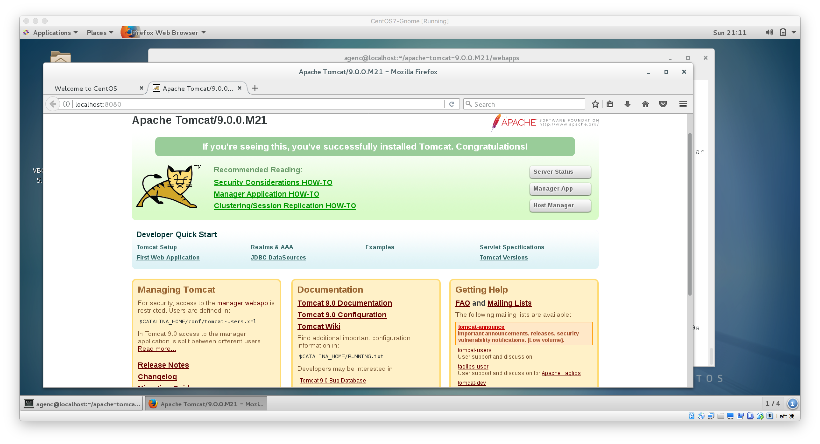

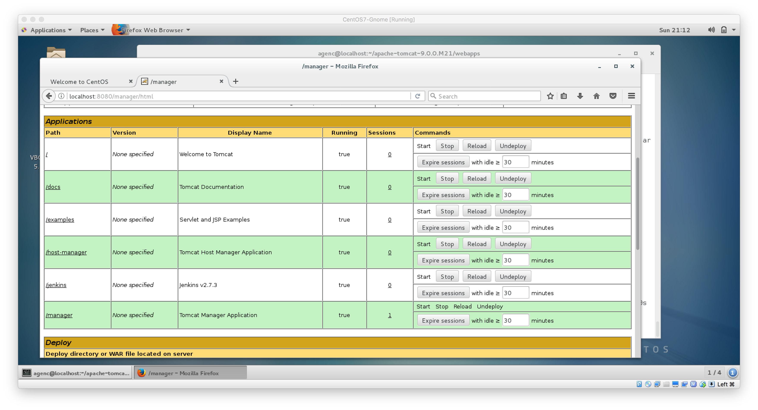

1. Get the password from :
   1. >> cat ~/Jenkins/Home/secrets/initialAdminPassword

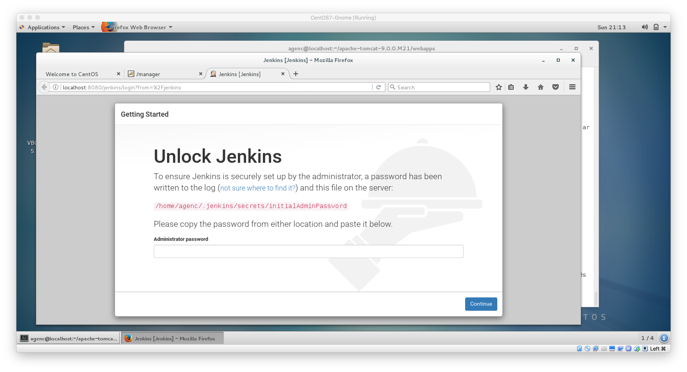

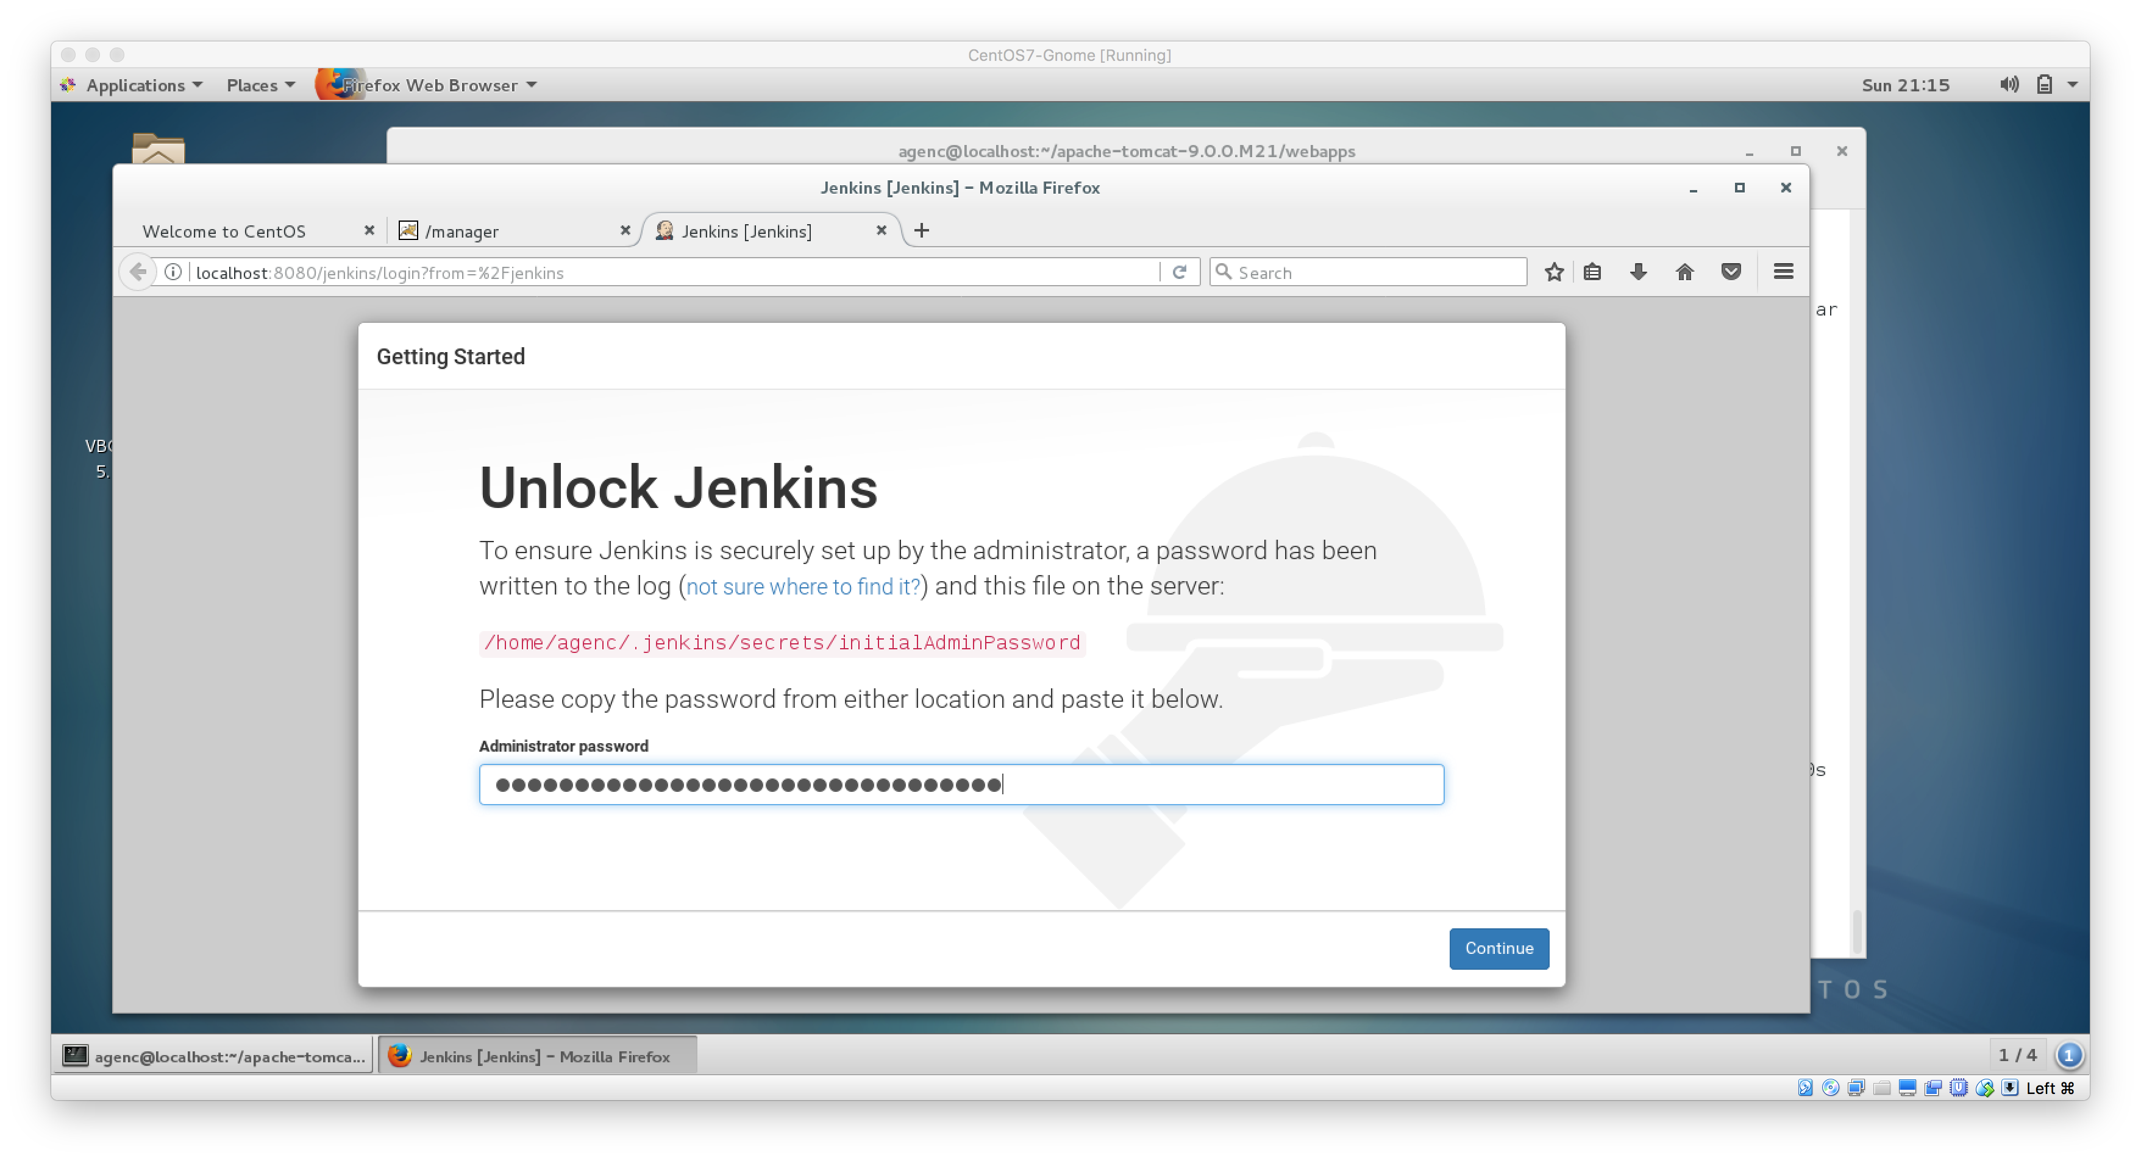

1. Install Suggested Plugins
   1. Follow the onscreen steps to install the suggested plugins

